**Cycle 2 Management Plan**

**User Story and Task Assignments**

The following user stories are under development this cycle:

* 3.1.1 Search for Parts
  + Collaboration: Entire team
  + Code: Entire team
  + Test: John B., Sean W., Shernovius B.
  + Review: Entire team
* 3.1.2 Select a Make
  + Collaboration: John B., Dillon C., Sean W.
  + Code: John B., Sean W.
  + Test: Ethan C., John B., Sean W.
  + Review: To be determined
* 3.1.3 Select a Year
  + Collaboration: John B., Dillon C., Sean W.
  + Code: John B., Sean W.
  + Test: Ethan C., John B., Sean W.
  + Review: To be determined
* 3.1.4 Select a Part Name
  + Collaboration: John B., Dillon C., Sean W.
  + Code: John B., Sean W.
  + Test: Ethan C., John B., Sean W.
  + Review: To be determined
* 3.1.5 Change the Search Year
  + Collaboration: Ethan C., Dillon C., Sean W., Shernovius B.
  + Code: Ethan C., Dillon C.
  + Test: Sean W., Shernovius B.
  + Review: To be determined
* 3.1.6 Clear the Search
  + Collaboration: Ethan C., John B., Dillon C., Shernovius B.
  + Code: Ethan C., Dillon C.
  + Test: John B., Shernovius B.
  + Review: To be determined
* 3.1.7 Purchase a Part
  + Collaboration: Entire team
  + Code: Ethan C., John B., Shernovius B.
  + Test: Dillon C., Sean W.
  + Review: Entire team
* 3.1.8: Pay for a Part with PayPal
  + Collaboration: Entire team
  + Code: Ethan C., John B., Shernovius B.
  + Test: Dillon C., Sean W.
  + Review: Entire team
* 3.1.9 Request Additional Information About a Part
  + Collaboration: To be determined
  + Code: To be determined
  + Test: To be determined
  + Review: To be determined

The following tasks are under development this cycle:

* Finalize UI design for mobile applications
  + Assigned to: Entire team
* iOS app: Implement improved UI for selecting search parameters (part of user stories 3.1.1-3.1.3)
  + Assigned to: John B., Dillon C.
* Android app: Implement improved UI for selecting search parameters (part of user stories 3.1.1-3.1.3)
  + Assigned to: Ethan C., Sean W.
* iOS app: Implement improved UI for returning list of search results (part of user stories 3.1.4 and 3.1.6)
  + Assigned to: John B., Dillon C.
* Android app: Implement improved UI for returning list of search results (part of user stories 3.1.4 and 3.1.6)
  + Assigned to: Ethan C., Sean W.
* iOS app: Implement improved UI for changing the search year (part of user story 3.1.5)
  + Assigned to: Dillon C.
* Android app: Implement improved UI for changing the search year (part of user story 3.1.5)
  + Assigned to: Ethan C.
* iOS app: Research implementing the PayPal SDK for payments (part of user stories 3.1.7-3.1.8)
  + Assigned to: John B., Shernovius B.
* Android app: Research implementing the PayPal SDK for payments (part of user stories 3.1.7-3.1.8)
  + Assigned to: Ethan C., Shernovius B.
* Implement ability to delete parts from MS Access database through the Web API when a part is purchased
  + Assigned to: Ethan C.
* Send invoice email to Willie’s Cycles when a part is purchased (part of user stories 3.1.7-3.1.8)
  + Assigned to: Dillon C., Sean W., Shernovius B.
* Finalize how the communication should work for requesting additional information about a part (part of user story 3.1.9)
  + Assigned to: Entire team
* Set up build system
  + Assigned to: John B.

**Gantt Chart**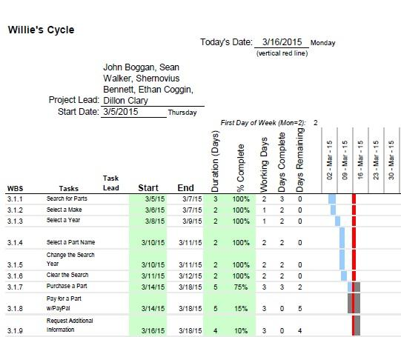

**Planned Code Freeze**

Our planned code freeze date is 3/29/15.